Resources from the FF/YM Zoom Group Gathering
May 14, 2020

Our focus during this session was on trauma and how it relates to the current situation with COVID-19. Next week, May 21, we will talk about how grief is being experienced in our current situation and also about ways to build resiliency.

Here are resources that were shared during out time together last Thursday:
(most are copied and pasted from our chat)
We talked about how moving our bodies and practicing mindfulness can help to counteract traumatic responses we may be experiencing:
- MI worked with headspace.com to create a resource page for Stay Home, Stay (MI)ndful - great mindfulness activities for all ages
https://www.headspace.com/mi

- Les Mills has free online classes, Body Flow is one of them. watch.lesmillondemand.com

Resources Lisa drew on for her presentation:
- Dr. Bessel van der Kolk- www.besselvanderkolk.com
- SAMHSA (Substance Abuse and Mental Health Service Administration)- www.samhsa.gov
- Wisconsin DHS (Department of Health Services)- www.dhs.wisconsin.gov

How To Lead When You Don’t Know Where You Are Going: Leading in a Liminal Season by Susan Beaumont. You can learn more about the author at: www.susanbeaumont.com

This was a good article that was shared in our chat:
https://religionnews.com/2020/05/12/from-flannelgraphs-to-zoom-churches-bring-sunday-school-home/

VBS resource from the Association of Presbyterian Christian Educators (APCE):
https://www.facebook.com/apcenet/photos/a.373523892663376/3501333896549011/?type=3&theater
FF-YM Zoom Gathering Resources
5-28-2020

Darci Warner shared the link to a Facebook Live event she attended that was put on by Ministry to Youth: How to Pivot Your Approach to Youth Ministry During COVID-19
https://www.facebook.com/ministrytoyouth/videos/178681953456972/?__tn__=%2Cd%2CP-R&eid=ARDmjfLUXer5JMlJRtEenyTrE1m41iHVdnpvHURH-hVAuj9zDoWwke_38YrviGYs2nCf4oFyOu_dFUW_
Darci also shared her “take-aways” from the FB Live event…
The tid-bits I took away:
1. Re-define the "win" (Stay faithful, don't beat yourself up, don't give up)
2. Do less--BETTER! (doing something well is more important then doing more)
3. Empower people to lead (students, adults/parents)
Be in front of the kids/youth. Let them know we are here! "We will show up even if no one else is showing up".
We didn’t really talk about these resources today, but…
From Traci Smith's Treasure Box Tuesday email this week: 7 Mindfulness Exercises for Children-
https://blog.beamingbooks.com/7-mindfulness-exercises-for-young-children?fbclid=IwAR09TLgpwr4dLzuvnX1Z0wD7Ret6fKdvlztw3j5ZsA18wFDdUl8JN9jZa1c
Another great resource shared by Traci Smith in her Treasure Box Tuesday email: https://www.journeywithjesus.net/PoemsAndPrayers/Edwina_Gateley.shtml
(The Journey with Jesus website (it’s a webzine for the global church) offers a weekly poem or prayer)

We did talk about NYE and the virtual opportunities that will be offered over the next two months. The first is this Sunday (May 31). Here is the information:
GATHER WITH US ONLINE FOR "LOVING YOUR NEIGHBOR IN QUARANTINE"
Even though our ability to gather in person has been delayed, we are able to continue the work of Jesus during these times. In looking to the beautiful example of resilience and wisdom exhibited through the migrant experience, we will gather together on Sunday, May 31 at 4 pm EST / 1 pm PST.
We will be led by Natalia Serna, Foundations of Faith and Jesus, and Rev. Rhina Ramos. Join us in this commitment to the love of neighbor both in quarantine and at all times as we engage in the conversation in real-time.
This video premiere and conversation will take place on Facebook, but you do not need a Facebook account to watch the video. Simply click on the link to watch live or after it airs.
The next NYE event will take place on June 28th:
SAVE THE DATE FOR OUR NEXT CONVERSATION -
CREATIVITY AND JUSTICE
IN QUARANTINE
Sunday, June 28, 4 pm EST / 1 pm PST
You will also want to check out the AMAZING song and video that was written for NYE. It speaks so well to our current circumstances even though it was written prior to COVID-19. I think the video would work well in any worship service. (Note: you will also see Jenn and her son in the video!)
NYE Video: "Together We're Strong"
http://www.uccpages.org/nye2020/together-were-strong/?inf_contact_key=2fd4fdd709575943f3150ac3f0e11e891b0a3f0fd3ee5d9b43fb34c6613498d7

We had a conversation about ministering to young adults. Cindy Birkner provided a resource that shares information on how young adults (18-25) are doing through the pandemic and offers important insight into the importance of faith in their lives, as well as a reminder that we make a positive impact in their lives when we are intentional about reaching out to them:

Summary:
- The survey consisted of a national panel of 508 respondents ages 18–25, with a margin of error of +/- 4% at a 95% confidence level, administered between March 24 and March 31, 2020.
- One in three respondents are sheltering in place alone.
- 63% of all respondents say that they do not feel as alone or isolated when people reach out to them.
- Among young adults who are sheltering in place with others, half still say that they feel alone, and nearly eight out of ten report feeling less lonely when a trusted adult from outside their household checks in on them.
- About 58% say they feel scared and uncertain, and 66% of those who feel this way say they don’t have anyone to talk to about their emotions. Thus, they feel isolated because no one is reaching out to them.
- Respondents are not experiencing a decrease in their faith; in fact, 35% increased their faith and 47% stayed the same.
- Nearly 46% have started new religious practices, and 43% have participated in at least one religious service online.
- Yet 50% of those who have attended an online service report that they don’t have anyone to talk to about how they are feeling, and 44% report feeling isolated because no one has reached out to them.
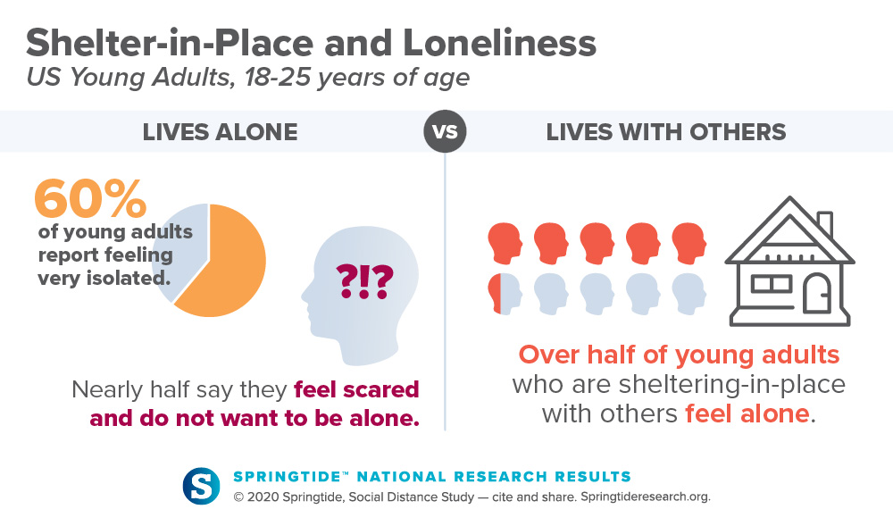
Yet, even among young adults who are sheltering in place with others, half of the participants say they feel alone. Many (39%) report their loneliness results from no one checking in with them.
The survey found that when a trusted adult outside their house connected with young people, nearly eight out of ten report feeling less lonely.
Springtide Social Distancing Study
Of those adults who reached out to young people, the most common connection was family and friends (89%), followed by teachers/professors (5%), bosses (2%), and clergy or faith leaders (less than 1%).
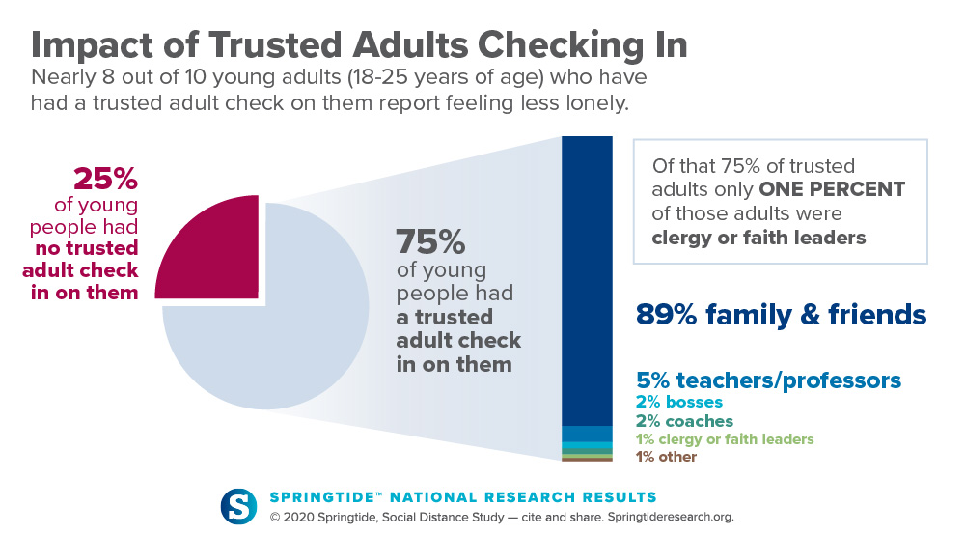

Effect on Faith and Religious Beliefs
During social distancing, the survey found that young adults are not experiencing a decrease in their faith. In fact, 35% report increased faith, while 47% report their level of faith staying the same. Almost half (46%) of respondents report having started new religious practices, and 43% have participated in at least one service online.
Seven out of ten people who watched an online service say that interacting with people, even virtually, makes them feel more connected. Yet, nearly half of those people still report feeling isolated because no one is reaching out to them individually.
Despite some young adults finding value in churches and religious or faith communities providing online rituals and virtual spaces during this time of social isolation, the survey found that what mitigates their experience of loneliness is the act of caring adults checking in and connecting with them.

“We believe there is an urgency for those working with young people to understand the need to be connected during this time of social distancing. This is an important moment for spiritual leaders to do what is at the heart of their faith.”
Josh Packard

